WEATHER CLIMATE WATER | 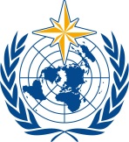  World Meteorological Organization  COMMISSION FOR WEATHER, CLIMATE, WATER AND RELATED ENVIRONMENTAL SERVICES AND APPLICATIONS  Second Session  17 to 21 October 2022, Geneva | SERCOM-2/Doc. 5.6(5)
Submitted by:
Chair
21.X.2022
APPROVED
AGENDA ITEM 5: TECHNICAL REGULATIONS AND OTHER TECHNICAL MATTERS
AGENDA ITEM 5.6: Disaster risk reduction and public services

Wmo coordination mechanism implementation Plan

GENERAL CONSIDERATIONS

WMO Coordination Mechanism (WCM) Implementation Plan Overview

The WCM Implementation Plan attached as an annex to draft Resolution ##/1 (EC-76), describes the proposed activities required to create a sustainable capability through which WMO can coordinate enhanced support to the United Nations (UN) and Humanitarian Agencies. The development of the WCM Implementation Plan was agreed at the eighteenth session of the World Meteorological Congress (Cg-18), through Resolution 14 (Cg-18) - Development of the Initial Concept for the WMO Coordination Mechanism to Support the Humanitarian Activities of the United Nations and Other Organizations.
The Implementation Plan will be built on the following principles:
(1) Support Members in the development of knowledge and understanding of the UN system to facilitate enhanced bilateral support;
(2) Use authoritative information, expert advice and products from WMO Members, including via Global Multi-Hazard Alert System (GMAS) once operational and designated Global Data-Processing and Forecasting System (GDPFS) Centres as the foundation on which it will be built upon and will be shared;
(3) Serve as a coordination conduit in complex, multi-sectoral or multi-country requests for information with and via Members;
(4) Leverage existing WMO networks, partnerships and WMO initiatives;
(5) Contribute to the development of fit-for-purpose mechanisms to gather requirements;
(6) Integrate expertise from Members through work accomplished through other WMO bodies (Technical Commissions, Regional Associations, etc.);
(7) Provide support to NMHSs, if requested and if events hinder their fulfilment of humanitarian requirements;
(8) Work normal office hours and will utilize Members information and advice. The WCM will act as a ‘landing point’ to help support the coordination of requests from the UN and Humanitarian Agencies (HA) and coordinate responses using Members information.
Using these principles the Implementation Plan will describe:
(1) The development of a Coordination and Briefing Team (CBT) through which to coordinate WMO’s support to the UN and HA. The CBT will be staffed by experts seconded from WMO Members and supported by the WMO Secretariat;
(2) A Feasibility Study to assess the benefits of developing a WMO network of regional experts tasked with providing dedicated support to UN and HA;
(3) Training support to both Members and the UN to improve the respective knowledge of WMO and UN / Humanitarian capability / operating procedures.

DRAFT RECOMMENDATION

Draft Recommendation 5.6(5)/1 (SERCOM-2)

WMO Coordination Mechanism Implementation Plan
THE COMMISSION FOR WEATHER, CLIMATE, WATER AND RELATED ENVIRONMENTAL SERVICES AND APPLICATIONS,
Recalling:
(1) Resolution 14 (Cg-18) – Development of the Initial Concept for the WMO Coordination Mechanism to support Humanitarian Activities of the UN and Other Organizations,
(2) Decision 9 (SERCOM-1) – WMO Coordination Mechanism to support the Humanitarian Activities of the UN and Other Organizations,
(3) Resolution 3 (EC-75) – UN Global Early Warning / Adaptation initiative, including the reference to ‘Coordinated communication for anticipatory action’,
Noting the coordination of enhanced support to the principle UN Humanitarian Coordination Forum], the Inter-Agency Standing Committee (IASC), other UN Organizations and Humanitarian Agencies provided by WMO since the start of the WCM development work in February 2020,
Further noting the further development of the WCM Concept, in particular through the development of the initial Information and Scoping Paper and through prototype service development and support to UN and Humanitarian Agencies,
Recognizing that the United Nations General Assembly Resolution 46/182, which stipulates Guiding Principles that include:
(1) Humanitarian assistance is of cardinal importance for the victims of natural disasters and other emergencies,
(2) Humanitarian assistance must be provided in accordance with the principles of humanity, neutrality and impartiality,
(3) The sovereignty, territorial integrity and national unity of States must be fully respected in accordance with the Charter of the United Nations. In this context, humanitarian assistance should be provided with the consent of the affected country and in principle on the basis of an appeal by the affected country,
(4) Each State has the responsibility first and foremost to take care of the victims of natural disasters and other emergencies occurring on its territory. Hence, the affected State has the primary role in the initiation, organization, coordination, and implementation of humanitarian assistance within its territory,
Recognizing further that WCM is to be developed and operated based on the said Guiding Principles of the United Nations General Assembly Resolution 46/182, and the WCM’s principles agreed at Cg-18 which include:
(1) The WCM contributors’ responsibilities will be based on their agreed voluntary commitment (mainly remote, specialized/tailored services), capacities, and regional and key specialization,
(2) NMHSs are responsible to support the UN and other humanitarian agencies’ country teams, and if a NMHS requires support it would request it from the WCM,
(3) Activities, information and advisory services provided to the users are properly recorded, evaluated and disclosed to the Members to ensure accountability of activities under WCM,
Emphasizing the fundamental role of National Meteorological and Hydrological Services (NMHSs) as the official and authoritative providers of early warnings for hydrometeorological hazards and the unique coordination role played by WMO in this regard and also for related environmental hazards in the context of the UN system,
Expresses its appreciation to the China Meteorological Administration (CMA), Deutscher Wetterdienst (DWD), UK Met Office and in particular MeteoSwiss through the Weather4UN Project for their support to the WCM development to date;
Having examined the WMO Coordination Mechanism Implementation Plan prepared by the Standing Committee on Disaster Risk Reduction and Public Services (SC-DRR) [P/SERCOM] [Czech Republic] in consultation with other subsidiary bodies (;
Decides: in consultation with relevant bodies, to take into account the following for EC consideration:
(1) The scope of UN agencies, IFRC and other institutions relevant to WCM be clarified;
(2) WCM is an activity for UN and humanitarian agencies based on their needs. A clear line between WCM activities and normal WMO activities for WMO Members based on their needs should be given. Member’s contributions, including those by RSMCs, to WCM is voluntary. GDPFS centres should be designed based on the needs of Members as stipulated in the GDPFS Manual;
(3) In accordance with the said principles, WCM’s supports to humanitarian assistance by UN and humanitarian agencies in territories of a Member should be provided with the consent of the Member concerned and in principle on the basis of an appeal by the Member. This should be incorporated into the operational procedures of WCM activities;
(4) A secured environment/platform should be developed where all the activities, including information and services provided to UN and humanitarian agencies under WCM should be fully transparent and accessible to all the WMO Members;
(5) Identification of regional needs;
Requests SC-DRR to further refine the Implementation Plan by incorporating the above considerations and submit it, through the President of the Commission, to EC-76 for its consideration;
Recommends to the Executive Council the adoption of WMO Coordination Mechanism Implementation Plan through the draft resolution provided in the annex to the present Recommendation.
_______________
Annex: 1

Annex to draft Recommendation 5.6(5)/1 (SERCOM-2)

GENERAL CONSIDERATIONS
A resolution of the United Nations General Assembly and various WMO decisions calling for the creation of a sustainable capability through which WMO can coordinate enhanced support to the United Nations and Humanitarian Agencies are recalled here below to inform the proposed resolution of the Executive Council:
(1) The United Nations General Assembly Resolution 46/182, which:
(a) Stipulates that “each State has the responsibility first and foremost to take care of the victims of natural disasters and other emergencies occurring on its territory”;
(b) Lays down the principles and framework for humanitarian assistance, and
(c) Highlights the importance of international cooperation to address emergency situations and the central and unique role the UN plays in providing leadership and coordinating the efforts of the international community to support the affected countries and the linking of short-term emergency assistance to longer-term capacity development
(2) The WMO Convention preamble reaffirms “the vital importance of the mission of the National Meteorological, Hydrometeorological and Hydrological Services in observing and understanding weather and climate and in providing meteorological, hydrological and related services in support of relevant national needs”, including inter alia in protection of life and property, contributing to sustainable development, meeting international commitments and contributing to international cooperation
(3) Article VI of the agreement between the UN and WMO, in which WMO “agrees to cooperate with and to render all possible assistance to the United Nations, its principal and subsidiary organs, in accordance with the United Nations Charter and the World Meteorological Convention, taking fully into account the particular position of the individual Members of the Organization which are not members of the United Nations”
(4) That the Seventeenth World Meteorological Congress (Cg-17) acknowledged the continued collaboration with the UN Office for the Coordination of Humanitarian Affairs (UNOCHA) in the development of procedural arrangements for the provision of meteorological and hydrological assistance to humanitarian contingency planning, preparedness, early warning, response and recovery activities
(5) Resolution 2 (Cg-17) – Implementation of the WMO Strategy for Service Delivery
(6) Decision 13 (EC-68) – Assistance to Humanitarian Agencies
(7) Decision 10 (EC-69) – Climate Services Information System Products to Support United Nations System Planning and WMO Members on Seasonal to Inter-Annual Timescales,
(8) Decision 3 (EC-70) – Further implementation of the WMO Disaster Risk Reduction Roadmap
(9) Decision 5 (EC-70) – Support to the United Nations and Humanitarian Agencies
(10) Resolution 3 (EC-75) – UN Global Early Warning / Adaptation Initiative

Draft Resolution ##/1 (EC-76)

WMO Coordination Mechanism Implementation Plan
THE EXECUTIVE COUNCIL,
Recalling:
(1) Resolution 2 (Cg-17) – Implementation of the WMO Strategy for Service Delivery,
(2) Resolution 14 (Cg-18) – Development of the Initial Concept for the WMO Coordination Mechanism to Support the Humanitarian Activities of the United Nations and Other Organizations,
(3) Decision 13 (EC-68) – Assistance To Humanitarian Agencies,
(4) Decision 10 (EC-69) – Climate Services Information System Products to Support United Nations System Planning and WMO Members on Seasonal to Inter-Annual Timescales,
(5) Decision 3 (EC-70) – Further Implementation of the WMO Disaster Risk Reduction Roadmap,
(6) Decision 5 (EC-70) – Support to the United Nations and Humanitarian Agencies,
(7) Resolution 3 (EC-75) – UN Global Early Warning / Adaptation Initiative,
(8) Resolution 46/182 of the United Nations General Assembly (A/RES/46/182 (undocs.org)),
Noting:
(1) That one of the key drivers in the WMO Strategic Plan is the need to strengthen production and delivery of accessible and authoritative meteorological and hydrological information and services to support the UN system’s needs on humanitarian and crisis management,
(2) The potential benefits of the Global Multi-hazard Alert System (GMAS) for the provision of strategic information at global and regional levels by WMO, as described in Resolution 13 (Cg-18) - WMO Global Multi-Hazard Alert System,
Considering that WCM should be developed and operated based on the respective Guiding Principles of the Resolution 46/182 of the United Nations General Assembly and the WCM’s principles agreed at Cg-18,
Noting further with satisfaction that Members have already expressed their support for the WCM through the provision of data, information, expert advice and in-kind contributions,
Recognizing the enhanced support provided by Members and the WCM development team to the principle UN Humanitarian Coordination Forum [Secretariat], the Inter-Agency Standing Committee (IASC) and other UN Organizations and Humanitarian Agencies since Cg-18,
Expresses its appreciation to the China Meteorological Administration (CMA), Deutscher Wetterdienst (DWD, German Weather Service), UK Met Office and in particular the Federal Office of Meteorology and Climatology MeteoSwiss through the Weather4UN Project for their support to the WCM development to date;
Approves the WCM Implementation Plan as provided in the annex to the present resolution;
Decides: to closely monitor and guide the development of the WCM Implementation Plan;
Requests:
(1) The Commission for Weather, Climate, Water and Related Environmental Services and Applications (SERCOM) to:
(a) Establish a process to ensure full accountability and governance of the activities of the WCM;
(b) Explore how best to incorporate the WCM in relevant WMO frameworks and normative documents such as the GDPFS Manual;
(c) With guidance from the EC, keep the implementation plan under review and make recommendations for update of the plan for EC consideration on a regular basis
(2) The Regional Associations to contribute to this endeavour in their respective regions;
(3) The Secretary-General to:
(a) Facilitate the WCM Implementation through the development of a resource mobilization plan;
(b) To develop options to ensure [Switzerland] the necessary resources in the WMO Secretariat to establish and manage the Coordination and Briefing Team (CBT) and present these to EC-77;
(c) To facilitate the embedding of experts from Members, preferably through secondments;
(d) Maintain and develop linkages of NMHSs with the UN and other humanitarian agencies;
(e) Encourage the continuation of existing initiatives;
(f) Report to the Executive Council on the above activities;
Urges Members operating global and regional GDPFS Centres to contribute to the implementation of the WCM;
Further urges Members to contribute to the WCM through the secondment of experts or other in-kind and/or financial support.
__________
Annex: 1

Annex to draft Resolution ##/1 (EC-76)

WCM Implementation Plan

Contents

Acronyms & Abbreviations 9
Preamble 10
Chapter 1 – Congress 18, Resolution 14 11
Context 11
Expectations from WMO Congress (Cg-18) 11
Linkages to Members, Constituent Bodies, Regional Associations, other WMO entities and UN Partners 13
Chapter 2 - The WCM 14
The WCM Coordination and Briefing Team (CBT) 14
Initial WCM CBT Deliverables 16
Chapter 3 - The WCM Implementation Plan Overview 16
Principles 17
Chapter 4 - Implementation of the WCM 18
Coordination and Briefing Team Implementation 18
The WCM Network of Advisers – Feasibility Study 21
WCM Training and related activities 22
WCM Communication Plan 23
Chapter 5 - Monitoring / Reporting / Governance 25
Implementation Plan Monitoring & Reporting 25
Risks 25
Governance 26
Chapter 6 - Conclusion 26
Annex 1 – Supplementary Documentation Links 27
Annex 2 - Current Activities Supporting the Development of the WCM 28
Annex 3 – CBT Secondee Requirements & Experience 31
Annex 4 – WMO Inter-Agency Standing Committee (IASC), Early Warning / Early Action Assessment Group Draft SOP Schematic 32
IASC SOP 32
Annex 5 – WCM Linkages with WMO Initiatives, Constituent Bodies, and other UN / HA initiatives 33
Annex 6 – Proposed initial monitoring and reporting indicators of the WCM 34
Annex 7 – Risks & Mitigation 35

Acronyms and Abbreviations

CBT Coordination and Briefing Team
ENSO SOP United Nations Standard Operating Procedure for the analysis and communication of potential El Niño, La Niña Impacts
GMAS Global Multi-Hazard Alert System
GSCU Global Seasonal Climate Update
IASC United Nations Inter Agency Standing Committee: principal UN Humanitarian response and coordination forum
GDPFS Global Data-Processing and Forecasting System
GFCS Global Framework for Climate Services
HA Humanitarian Agencies
HC United Nations Humanitarian Coordinator
IFRC International Federation of Red Cross
INFCOM Commission for Observations, Infrastructure and Information Systems
NMHS National Meteorological and Hydrological Services
RCOF Regional Climate Outlook Forum
RCC Regional Climate Centre
RSMC Regional Specialized Meteorological Centre
SERCOM Commission for Weather, Climate, Water and Related Environmental Services and Applications
SC-DRR Standing Committee for Disaster Risk Reduction
UNITAR United Nations Institute for Training and Research
UNOCC United Nations Operations & Crisis Centre (in New York)
UNOCHA United Nations Office for the Coordination of Humanitarian Affairs
UN RC United Nations Resident Coordinator
UN SG United Nations Secretary-General
WCM WMO Coordination Mechanism to support the Humanitarian Activities of the UN and other organizations
WFP World Food Programme
WMO World Meteorological Organization

Preamble
For many years, WMO’s National Meteorological and Hydrological Services (NMHSs) have supported Humanitarian and United Nations in early action planning and in responses to extreme weather and climate events, with the likes of the Global Framework for Climate Services (GFCS) providing a focal point to enhance this service delivery. However, needs are evolving and the access and integration of timely hydrometeorological information in the management of humanitarian crisis has becomes increasingly important. This was emphasized still further in the UN SG statement on World Met Day 2022 (and subsequently endorsed at EC-75) in announcing that WMO would lead an initiative to ensure that everyone on Earth be protected by Early Warning Systems within the next five years.
In 2019, WMO Members endorsed Resolution 14 at the eighteenth World Meteorological Congress which tasked the appropriate body (SERCOM) to develop a WMO Coordination Mechanism (WCM) to support the Humanitarian Activities of the UN and other organizations. The main objective of the WCM is to enable access to authoritative weather, water and climate information and the provision of expert advice from WMO Members to the UN and other humanitarian agencies in respect of Anticipatory Action and Crisis Support.
Resolution 14 involves two overarching deliverables:
o Develop an Implementation plan for the WCM based on the initial Concept and voluntary contributions of WMO Members
o Provide recommendations for incorporating the WCM in relevant WMO frameworks and normative documents such as the Global Data-Processing and Forecasting System (GDPFS) Manual (with the relevant WMO bodies).
To develop an implementation plan for the WCM and provide recommendations regarding its processes, an Expert Team (ET-WCM) was put in place representing WMO Members and humanitarian organizations. Based on requirements documented in the initial Information and Scoping Paper and elsewhere, prototype activities were initiated, highlighting WMO Members expertise. Other activities were also taken forward to help better understand requirements, including scoping training requirements for both WMO Members and the UN and Humanitarian Agencies (HA).
The WCM Implementation Plan details the context and principles of the WCM followed by the description of the implementation, including suggestions for governance and reporting mechanisms. Annexes include examples of current prototype work, other activities and links to additional documentation

Chapter 1 Congress 18, Resolution 14

Context
Resolution 46/182 of the United Nations General Assembly stipulates the principles for humanitarian assistance and indicates that each sovereign state has the ‘primary responsibility to take care of the victims of disasters and other emergencies within its territory’ (Annex 1 – Supplementary Documentation Links).
UN-WMO Agreement
Recalling:
(3) Article VI of the agreement between the UN and WMO, in which WMO ‘agrees to cooperate with and to render all possible assistance to the United Nations, its principal and subsidiary organs, in accordance with the United Nations Charter and the World Meteorological Convention, taking fully into account the particular position of the individual members of the Organization which are not members of the United Nations’

As part of the agreement between the UN and the WMO (Article VI, as indicated within the WMO Convention and its Strategic Plan), the WMO Members States and Territories play a ‘vital’ role in their support to the ‘protection of life and property, contributing to sustainable development, meeting international commitments and contributing to international cooperation’.
As humanitarian crisis can be brought upon, or exacerbated, by weather and climatic extreme events, information produced by WMO Members is pivotal in increasing in the resilience of populations facing extreme events and in reducing the risks of disasters through enhanced support provided to the UN and Humanitarian Agencies (HA).

Expectations from WMO Congress (Cg-18)
During the eighteenth World Meteorological Congress, the WMO Members endorsed the establishment of the ‘WMO Coordination Mechanism to support the Humanitarian Activities of the UN and other organizations’ (henceforth named WCM), which overall objective is to facilitate the access to authoritative weather, water and climate information from Members and the provision of expert advice to the United Nations (UN) and other humanitarian agencies in order to support requests in anticipation of, during or after hydrometeorological hazard situations.
Resolution 14 from Cg-18 and its annex, indicates that:
- There is an urgency to facilitate access to authoritative information and expert advice supporting humanitarian action and decision-making.
- The framework of the WCM to include the requirements of the WMO community and that of the UN and other humanitarian agencies.
- This framework will be based on collaborative partnerships between WMO Members and the humanitarian communities supporting the linkages between NMHSs and the UN and other humanitarian agencies.
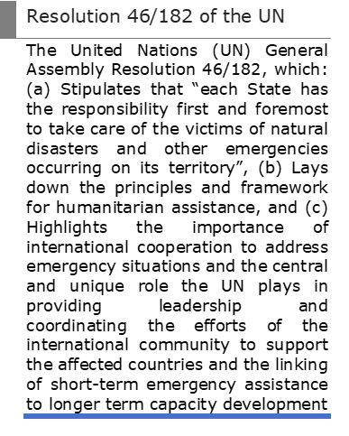
To proceed with the WCM concept, the WMO Cg-18 requested that an Implementation Plan for the WCM be developed based on voluntary contributions of Members and which also recommended governance, required resource mobilization, and reporting and accountability processes.
The WCM will be developed on the following understandings. It will:
- Support Members in the development of knowledge and understanding of the UN system to facilitate enhanced bilateral support,
- Use authoritative information, expert advice and products from WMO Members, including via GMAS once operational and designated GDPFS Centres as the foundation on which it will be built upon and will be shared,
- Serve as a coordination conduit in complex, multi-sectoral or multi-country requests for information with and via Members,
- Leverage existing WMO networks, partnerships and WMO initiatives,
- Contribute to the development of fit-for purpose mechanisms to gather requirements,
- Integrate expertise from Members through work accomplished through other WMO bodies (Technical Commissions, Regional Associations, etc),
- Provide support to NMHSs, if requested and if events hinder their fulfilment of humanitarian requirements,
- Work normal office hours and will utilize Members information and advice. The WCM will act as a ‘landing point’ to help support the coordination of requests from the UN and HA and coordinate responses using Members information.
Following WMO Cg-18, WMO’s Services Department enhanced its engagement with UN and HA. This catalysed requests for advice and information and the opportunity to further engage with core elements of the UN Anticipatory Action system, namely the UN IASC and the multi-sectoral UN ENSO Impact Analysis. With the excellent contributions from Members and WMO Regional Offices, it has been possible to support this work and other ad hoc requests. These have also helped develop an increased understanding of requirements for a WCM and enable the development of prototype impact assessments, briefing products and infographics through the MeteoSwiss Weather4UN pilot project and other initiatives. Annex 2 describes some of these initial activities.
Providing this support and advice has also helped inform how the WCM will interact with Members. Some requests (received during normal working hours) have required a quick response, whereas others such as the IASC require input on a regular pre-determined frequency. Lead time for response to requests will thus have impacts on how the WCM reaches out to Members and organizes its work plan. Figure 1 highlights some of the proposed WCM related activities with the X Axis detailing the response time (during normal working hours) and the upper and lower boxes detailing the interaction between the WCM / NMHS / RCC / RSMC and others.
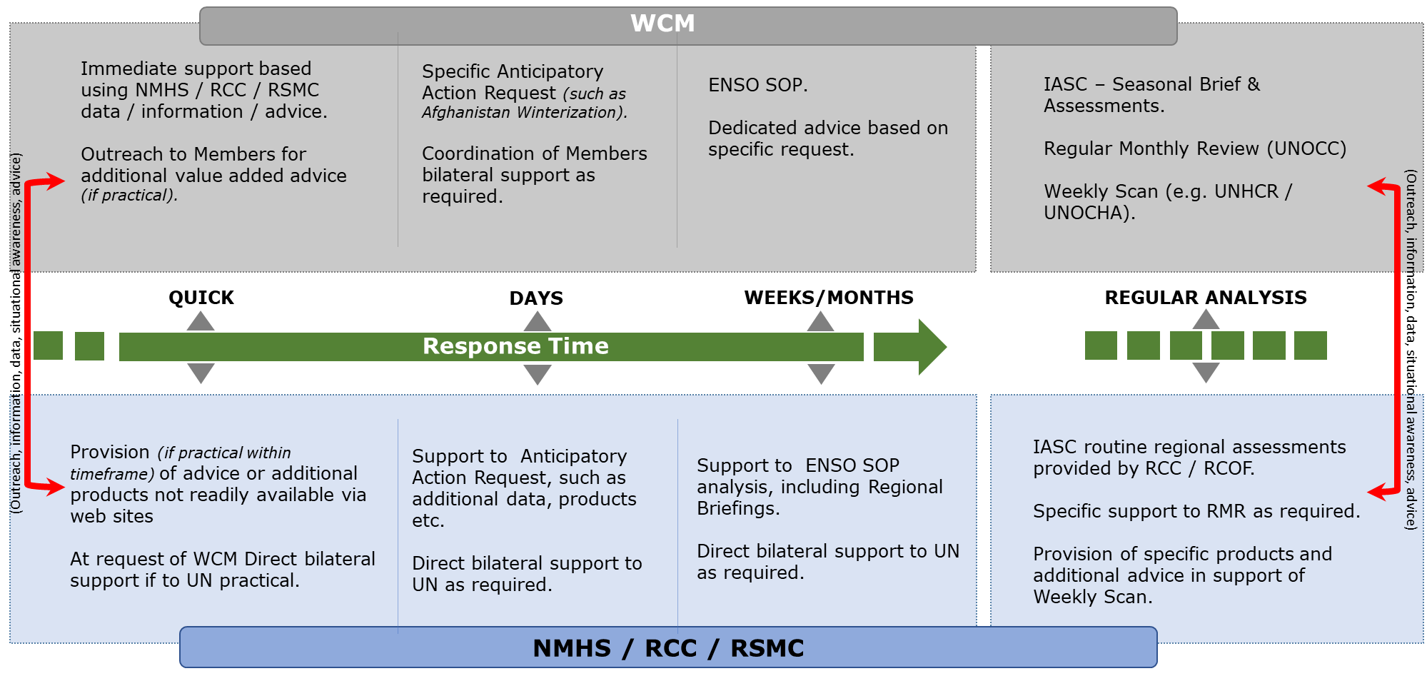
Figure 1: WCM Response Times and interactions with NMHS, RCC, RSMC

Linkages to Members, Constituent Bodies, Regional Associations, other WMO entities and UN Partners
The broad range of support required by the UN and Humanitarian Communities mandates an approach across the whole of WMO. As such, the WCM will be required to develop linkages with Members, Regional Associations, Constituent Bodies, other WMO entities and UN Partners. Some of these will require formal Terms of Reference, Memorandums of Understanding, or the agreement of Standard Operating Procedures. Others may require additional outreach as indicated within the WCM Communications Plan or to simply facilitate the development of linkages between NMHS / RCC etc and the UN / HA. Relationships with stakeholders developed in the context of the Implementation of the WCM and thereafter throughout its lifetime will be essential and require underpinning support documentation.
As the WCM is implemented, it will become increasingly important to formally establish and maintain enhanced and collaborative dialogue with other activities initiated by the WMO community such as the ongoing work in respect of the UN Early Warning / Adaptation initiative, the GMAS, the development of the ENSO Lead Centre, and the Objective Seasonal Forecasting, and their associated oversight bodies.

Chapter 2 The WCM
The overall objective of the WCM is to provide access to authoritative weather, water, climate information and expert advice from Members to the UN and HA. In order to fully realize this objective, Members and Humanitarian Agencies will be required to support the WCM development in terms of the provision of expert advice, in understanding new requirements, in service design, delivery, and innovation.
Central to facilitating the provision of authoritative advice and expertise will be the development of the core WCM Team, known as the Coordination and Briefing Team (CBT). Based on the requirements and evidence to date, this team will consist of:
• Experts in Meteorology, Hydrology, Seasonal Forecasting, Data Science and Humanitarian Anticipatory Action and Response, seconded from Members and our UN Partners, responsible for liaison with Members and coordination of support activities (Annex 3 [SEC] provides an outline Job Specification)
• WMO Secretariat Staff , responsible for direct liaison and briefing into the UN as required and overall management of the CBT.

The WCM Coordination and Briefing Team (CBT)
For the WCM to be sustainable and remain relevant, it must facilitate the provision of timely advice and support by aggregating information developed by Members, by helping to coordinate responses to requests by Humanitarian and UN colleagues and/or facilitate linkages with Members. It will also provide a framework for stakeholder engagement across the broad UN Anticipatory Action arena (Figure 2).
The CBT will be tasked with coordinating WMO support to the UN and HA. The team will be based within the WMO Secretariat in Geneva, will work normal office hours, and will not replace or duplicate the operational services and advice provided by WMO Members. The CBT Terms of Reference can be described under five key themes:
• Coordination of WMO response to specific requests from UN and HA for support made to the WMO Secretariat in Geneva,
• Provision of WMO input to routine UN Risk and Horizon Scanning activities,
• Monitoring and reporting on specific Anticipatory Action thresholds,
• Evaluation of new and emerging requirements,
• Briefing into UN or humanitarian analysis discussions as required.
To underpin the themes listed above, the CBT will perform the following tasks:
• Act as key landing point for Members requiring help to underpin bilateral or regional support to UN or HA,
• Coordinate (when required) interfaces between Members and the UN & HA,
- Coordinate broader WMO response to specific events or crisis when required, such as what was done for the SE Europe Refugee Crisis in 2015/16,
• Liaise with stakeholders across the UN and Humanitarian Communities
• Curate (collect and assemble) Members data and authoritative information in support of UN & HA multi-sectoral analysis,
• Translate this information into non-technical language for assimilation into UN / HA analysis and decision-making processors,
• Develop specific UN / HA focused infographics, other products and new ways of presenting expert advice and analysis,
• Develop standards, guidelines, operating procedures, and quality assurance mechanisms,
• Design services in partnership with Members and the UN / HA,
• Work with UN, HA and other partners to further develop Risk, Vulnerability and Impact Assessments.
WMO Members and UN partners will support the WCM through the provision of available products, services and expert advice, and in providing opportunities for secondment of personnel into the WCM with requirements for support from the WCM being defined by the UN & HA. Humanitarian agencies will also help WMO Members and the WCM by providing situational awareness, information with respect to vulnerabilities, as well as feedback regarding hydrometeorological information provided by the WCM.
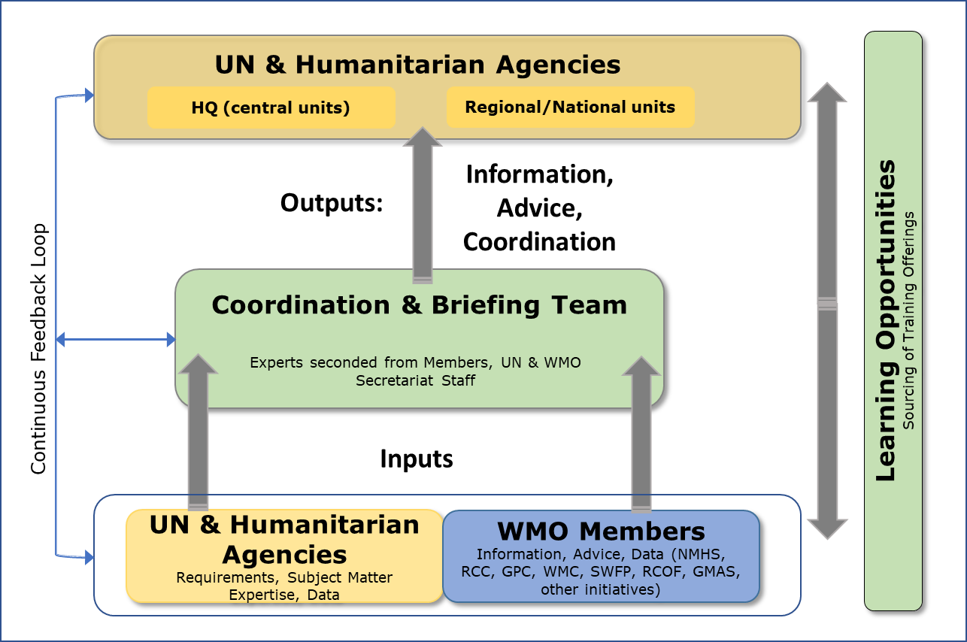
Figure 2: The WCM

Initial WCM CBT Deliverables
As discussed, the WMO Secretariat has been actively supporting the UN across areas of Anticipatory Action since Resolution 14 was endorsed in 2019. The WCM CBT will have as an initial mandate to continue the development and delivery of the following initiatives:
• The Monthly Inter-Agency Standing Committee Risk and Early Warning Analysis,
• The Inter-Agency Standing Committee ENSO Cell Analysis,
• Major multi-agency analysis such as that recently supported for the Horn of Africa,
• Service design to support specific UNOCHA operations
• Activities to support to the WMO representative in the UNOCC as required.
It is expected that other initiatives would be identified as the WCM matures.

Chapter 3 The WCM Implementation Plan Overview
The WCM Implementation Plan presents a path forward towards the development of mechanisms supporting the exchange of information between the WMO community and the UN and other HA in addition to identifying opportunities for strengthening the capacities of all.
This plan defines Work Packages to:
• Develop core capabilities that will enable the continuation and enhancement of existing support work through the establishment of a CBT,
• Assess the benefits of developing a regional support mechanism,
• Enhance the collective Members / UN and HA understanding of institutional and operational mechanisms through the development, identification and facilitation of training and knowledge sharing activities,
• Define and formalize linkages other WMO entities (Members, Expert Teams, RCC, RSMC, etc),
• Implement relevant governance monitoring and reporting mechanisms.
• The WCM Implementation Plan also references the WMO’s Strategy for Service Delivery, adheres to the ‘Considerations for Implementation’ as agreed at Cg-18 (Figure 3) and aims to support the ever-evolving landscape of disaster risk reduction through the engagement of Members.
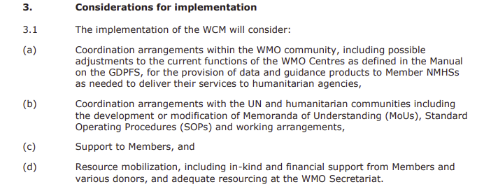
Figure 3: Cg-18, Resolution 14 – Considerations for Implementation

Principles
Early action and crisis response require a continuous dialogue to ensure that WMO community-led services remain relevant and that improvements can be instated through lessons learned, research, and innovation.
Implementing the WCM will be a challenging endeavour, some initiatives will evolve from current activities whereas others will be part of innovative approaches. The following principles will help guide the successful implementation of the WCM:
• Engagement with WMO Members, Regional Associations, Technical Commissions, and other constituent bodies,
• Evidential based development and implementation,
• Iterative, using pilot ‘activities’ to assess and measure benefits, time, costs, quality etc,
• Optimal use of synergies with existing initiatives (Services, Products, Outreach)
• Prioritization of developments to ensure sustainability of existing ‘best endeavours’ support currently provided through the WMO Secretariat,
• Monitor progress and assure quality standards against pre-agreed metrics,
• Ensure agile governance mechanisms with a formal role for ‘users’ outside of WMO,
• Develop communication and outreach to ensure stakeholders are kept informed of progress.

Chapter 4 Implementation of the WCM
The Implementation Plan reflects WMO Members and the UN / HA inputs into the WCM, as well as the responsibilities of the Coordination and Briefing Team (CBT). The Plan will also address the resources which are necessary for the execution and sustainability of the WCM.
The prime focus of the WCM Implementation Plan is the development and implementation of the CBT, providing the transition between current activities based on best endeavours to a more sustainable and expanded support. Parallel activities related to training and knowledge sharing, formalization of linkages with other WMO initiatives and implementation of formal monitoring, reporting and governance mechanisms will also take place throughout the WCM Implementation. A Feasibility Study regarding the development of a network of regional advisers is also proposed. Figure 4 provides a high-level overview of these key Work Packages.
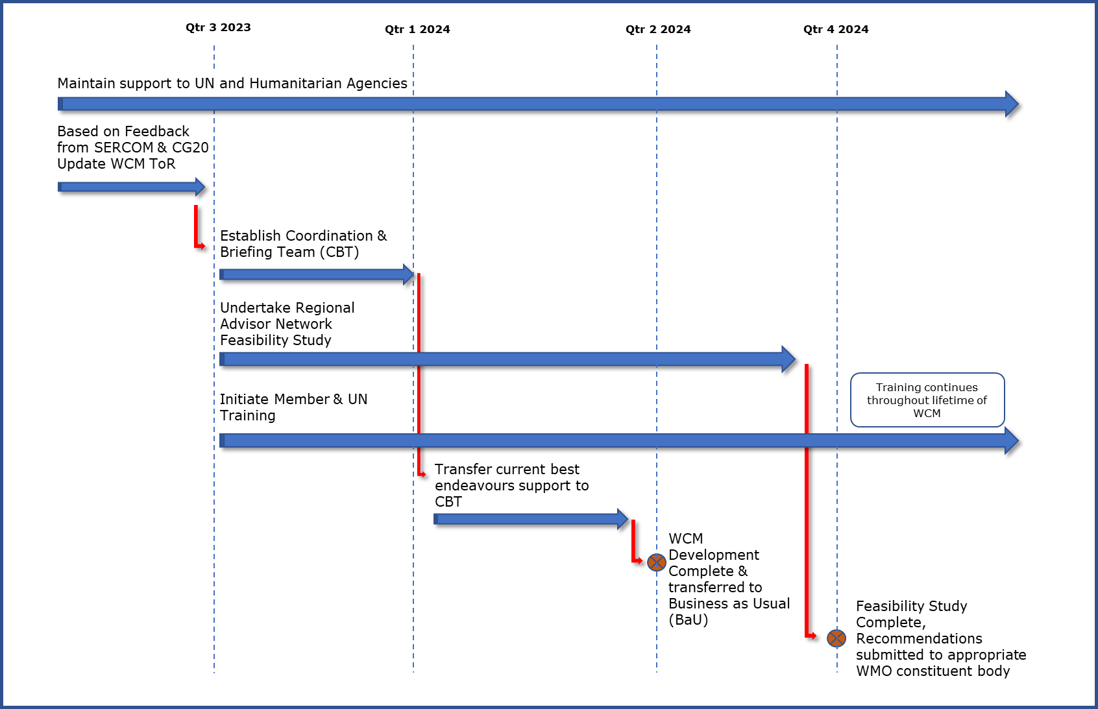
Figure 4: WCM Implementation Plan Overview

Coordination and Briefing Team Implementation
Developing the CBT from a concept into a fully functioning and sustainably resourced team is the principle WCM Implementation Work Package activity. Its implementation is described by several dedicated activities (Table 1) of which some would be initially led by the WMO Secretariat while the CBT gain familiarity with their duties.
Table 1: Implementation Plan for the Coordination and Briefing Team
(priority tasks only)
Work Package/ Milestones | Description | Detail | Proposed Timeline
1. CBT Terms of Reference Review | Review and finalize the CBT ToRs | • Draft CBT Terms of Reference are proposed in Chapter 4, however these are subject to further discussions during SERCOM & Cg-20. Work will be required to finalize the TORs and account for any modifications or amendments | QTR 3 2023
2. CBT Responsibilities | Finalize functions and responsibilities, level of experience and expertise for team members. Determine required academic, knowledge, experience and competencies | • Define requirements for Secondment of Experts from Members  • Define requirements for UN representation in CBT  • Define requirement of WMO Secretariat for WCM resources | QTR3 2023
3. CBT Resource Mobilization | Determine process for outreach and recruitment according to established requirements | • Finalize resource mobilization mechanisms with Members  • Work with Members to identify appropriate staff and complete secondment agreements into WMO ensuring regional and gender balances | QTR4 2023
4. CBT UN Support Schedule development | Design work schedule considering initial SOP development and associated resource mobilization | Through WMO Secretariat & CBT:  • Commence training of CBT Team Members  • Further develop IASC and ENSO Cell SOP  • As required, update / create new MoU with UN agencies  • As required, establish formal collaboration and support agreements with RCCs, RSMC, RCOF’s and other WMO constructs  • Development Data / Product Management procedures  • Establish process for responding to new requests for support | QTR3 2023 – QTR3 2024
5. Transition current Best Endeavours support into CBT | Following the development of the CBT, transition the existing UN support activities into the WCM | • Complete CBT Team Training  • Handover UN support responsibilities from existing WMO Secretariat staff to CBT | QTR4 2023 – QTR2 2024
6. Work plan implementation | Throughout lifetime of CBT enhance existing SOPs and development additional SOPs as required. These will determine the work schedule (Annex 4 provides a schematic overview of the draft IASC SOP as an example) | • Develop and prototype infographics, other products, new ways of presenting advice and analysis  • Develop thresholds or triggers in partnership with Members, UN and HA  • Determine thresholds of vulnerabilities  • Determine mechanisms of communication or interface between the Coordination and Briefing Teams and the Humanitarian Agencies
7. Knowledge sharing – learning opportunities | Work with UN and Humanitarian Agencies to develop appropriate knowledge sharing mechanisms to ensure full understanding of requirements, risks, vulnerabilities | Coordinate with the WMO Members Services department and other UN counterparts | QTR4 2023 – QTR2 2024
8. Development of support tools & briefing products | Work with Members and UN agencies to develop required support tools | Development of required tools and briefing products to aid analysis and translation of Members information as required | QTR3 2023 – QTR4 2024

The WCM Network of Advisers – Feasibility Study
UN and Humanitarian Agencies have a strong regional and country presence, led by Resident Coordinators and Humanitarian Coordinators (UN RC, HC). Complementary to this, the WMO has a mature network of RSMCs which have the technical capability to provide advice on hydrometeorological events. WMO Regional Climate Centres and Severe Weather Forecasting Programme centres also continue to expand.
Developing a regional mechanism of WCM UN and Humanitarian Agencies Advisers may have benefits such as complementing the work and coordination with the CBT, providing recognized regional focal points for the UN and Humanitarian Agencies and outreaching to Members for the required support and advice. This regional approach may help develop a cadre of experts who understand the regional hydrometeorological risks and vulnerabilities and develop an increased knowledge of UN and Humanitarian operation and policy development.
To fully assess the benefits the WCM Implementation Plan proposes the completion of a Feasibility Study. This study will address:
• Regional requirements
• Existing WMO Member Support arrangements
• Interfaces to existing WMO Regional Networks (and collaborative opportunities) and other UN regional centres (for example, the African Union)
• Technical capabilities and infrastructure
• Alignment with existing WMO policy areas and requirements for updates in the GDPFS Manual
• Interfaces to capacity development and donor projects
• Training and other learning opportunities
Lessons learned from the establishment of the CBT and that of current regional centres will support the feasibility assessment for this network.
Tasks required to develop the network are designed to inform requirements and potential implementation mechanisms (Table 2).

Table 2: Implementation Plan for the Network of Regional Advisers
Work Package Title | Description | Detail | Proposed Timeline
1. Finalize ToR for Assessment | Complete Assessment ToR | • Following SERCOM and Congress amended proposed ToR as required | QTR3 2023
2. Feasibility Assessment | Undertake Assessment and provide recommendations. | • Design and agree approach for Assessment, including specific oversight procedures as required  • Undertake Assessment ensuring synergies are maintained with GDPFS, WIS Regional Centres, UN regional Structure and other Stakeholders, also building on any initial lessons from the Implementation of the CBT  • Identify and agree appropriate resource mobilization mechanisms  • Complete and circulate report to appropriate WMO body for review | QTR3 2023 – QTR2 2024
3. Implementation (based on appropriate approvals) | Subject to approval Implement Regional Adviser Network including updating required WMO guides such as GDPFS are required. | • Design implementing and governance arrangements  • Implement network and ensure technical capability  • Recruitment of staff and training as required | QTR1 2024 – QTR4 2024

WCM Training and related activities
Both WMO Members and UN / HA colleagues agree that it would be beneficial to gain a more in-depth understanding of their respective Operational, Policy, Anticipatory Action and Response domains.
The WCM will therefore look to enhance this understanding through the identification of specific training requirements and the sourcing of appropriate training and knowledge products to support WMO Members and their UN counterparts.
To initiate this work, a Training Needs Assessment (TNA) was commissioned during the spring of 2022 during which members of the ET-WCM, the WMO Secretariat personnel and representatives from humanitarian organizations were surveyed. Training requirements in the context of the WCM were identified for WMO Members and for Humanitarian organizations and a series of potential available training resources was compiled on the WMO Moodle platform. (See Annex 1 for link to TNA).
Within the construct of the WCM Implementation Plan, the next phase is to facilitate the delivery of this training (Table 3). At this point it must be emphasized that the WCM will not have a training function per se but will look to leverage training opportunities within existing delivery modalities such as projects, programmes, Members (through Regional Associations), Humanitarian collaborators, and in coordination with the WMO Members Services department (specifically the Training & Education Programme, the WMO Global Campus and the Capacity Development Panel), Donors and Development partners. In addition, where on-line training is available, the WCM will look to support Members in their participation.
Additional training will also need to be considered for the members of the Coordination and Briefing Team and for any future Network of Regional Advisers.
Table 3: Implementation Plan for Training
Work Package Title | Description | Detail | Proposed Timeline
Pilot Training | Initial training package evaluation | • Work with a number of WMO Members to undertake and further evaluate some of the ‘on-line’ training identified in the TNA, and likewise with the UN and Humanitarian colleagues | QTR4 2023
Develop long-term training plan | In partnership with Member Services, Regional Associations, and Technical Commissions design programme of training for Members which can be implemented through existing modalities | • Based on the feedback from those undertaking the pilot training develop an appropriate training package or suite of training materials that can be used by Members  • Coordinate with Members Services to maintain and update training packages as required | QTR1 2024

WCM Communication Plan
The WCM Communication Plan will target WMO Members, the UN and Humanitarian Agencies will promote the WCM initiative and its proposed implementation by addressing the following:
• Increase awareness of the WMO among UN and Humanitarian stakeholders and promote partnerships
• Develop opportunities to promote the expertise of WMO Members and particularly that of the NMHSs and showcase the various products developed by the community and the WCM
• Increase understanding of the requirements of UN and Humanitarian stakeholders for access and use of hydrometeorological information of various scales adapted to their needs
• Share the importance of a holistic view to enable the assessments of potential impacts as an outcome of significant weather, climate and water events
• Promote learning opportunities for WMO Members and the UN and Humanitarian Agencies
• Ensure the sustainability of the WCM through resource mobilization and funding opportunities
As the WCM sits under the umbrella of DRR activities, it is proposed that communication products of the WCM also be integrated within a holistic view of DRR activities, in addition to stand-alone outreach of the WCM initiative. Proposed products include:
• 2-pager synopsis of the WCM initiative for general audience, available through the WMO WEB and other virtual platforms
• Side-event presentations or information sessions
• Presentations for Regional Associations, Regional Climate Forums
• Distribution to WMO’s Education and Training communities as well as those of the UN (ex: UNITAR)
• Communication products for humanitarian agencies (TBD)
Table 4 – Roll out of communication initiatives (preliminary)
(1) June – December 2022 | (3) June – December 2023
WMO Executive Council – June 2022 | WMO Congress
WMO SERCOM – October 2022 | Relief WEB – UNDRR
WMO Regional Associations meetings | GFCS regional consultation meeting
(2) January – June 2023 | WMO associated DRR activities
Humanitarian Networks and Partnerships Week (under the auspices of UNOCHA) – Spring 2023 | Other capacity development activities of which the WMO Global Campus and calendar
Regional and National Climate Outlook Forums
WMO Capacity Developmental Panel (Winter – Spring 2023)

Chapter 5 Monitoring / Reporting / Governance
Monitoring progress towards the Implementation of the WCM and establishing the longer-term governance mechanisms are vital for the WCM to realize a sustainable future.

Implementation Plan Monitoring & Reporting
For the Implementation Plan of the WCM, focus is placed on the implementation of the CBT as it is the core underpinning capability. This and the other implementation related activities will be overseen by an oversight group / team as advised by SERCOM which will monitor progress towards the delivery of specific milestones (Table 5) and other indicators (Annex 6[SEC]) and provide and authoritative decision-making body should this be required.
Table 5: Subset of CBT Implementation Milestones
Milestone | Date
Oversight Group established & ToR agreed | October 2023
Resource mobilization and training for CBT are completed | January 2024
WCM support agreements with RCCs, RSMCs and others are established | March 2024
Long-Term WCM governance arrangements are agreed | April 2024
Data Management Policy is implemented | June 2024
Transition from best endeavours support to CBT completed | June 2024
Prior to the transition from a ‘best endeavours’ support towards the CBT, the Oversight Group/ Expert Team will also be responsible for:
• Ensuring that agreed standards as defined between the CBT and UN/HA for ongoing support to the UN and Humanitarian Agencies are maintained
• Ensuring that WMO Members, through the respective Constituent bodies, remain engaged
• Monitoring progress towards the completion of the Regional Network Advisers Feasibility Study and the implementation of training offerings
• Timely after-event reviews to evaluate data received, infographics and other products which were generated, as well as briefing provided and the response generated for events
• Production of regular progress reports to the appropriate WMO constituent body

Risks
Development of the WCM is not without risks and these will need to be carefully managed both during and following the completion of implementation. Perhaps the most significant risks are that relating to resourcing as the proposed model of seconding Experts into the CBT may be difficult to realize during the current economic climate.
Resourcing and other possible risks along with proposed mitigation actions are detailed in Annex 7[SEC].

Governance
During the lifetime of the WCM Implementation and Group or Team as advised by SERCOM will need to be established to monitor progress and provide the required level of assurance. As per the current Expert Team, this will need to be comprised of experts from both WMO Members and the UN / HA community.
Alongside monitoring duties long-term governance arrangements will also need to be considered i.e. those which are put in place post implementation. This arrangement will need to consider three key elements:
• Quality assurance of ongoing service delivery, including maintenance of appropriate resources
• Service enhancements and change management
• Strategic considerations and maintenance of visibility across the WMO / UN / HA arenas.

Chapter 6 Conclusion
In order to facilitate the provision of timely information and expertise developed by the WMO community to the UN and Humanitarian Agencies, and hence enable Anticipatory Action by Humanitarian agencies, the WCM will
• Aggregate authoritative hydrometeorological information and advice developed by the WMO community for the UN and Humanitarian Agencies
• Leverage WMO networks, in doing so, and facilitate the coordination with the Humanitarian agencies through its Coordination and Briefing Team and, eventually, the WCM Network of UN and Humanitarian Advisers
The WCM will also have a keen capacity development mandate by supporting Members in the development of competencies and knowledge with respect to the UN system, and likewise identified learning opportunities that could be taken up by UN counterparts will enhance their understanding of hydrometeorological phenomena and the WMO system. This will facilitate bilateral collaboration and coordination within and hopefully, beyond the WCM.
This implementation plan for the WCM sets out the main components and activities to be implemented as well as some of their milestones. The WMO community and its Members have key roles in the success of the implementation, coordination activities and the sustainability of the WCM through their engagement in supporting resource mobilization within this initiative as well as ensuring linkages and sharing information they produce.

Annex 1 Supplementary Documentation Links
(Please note only Cg-18 – Resolution 14 is translated into the official WMO languages)
• Cg-18, Resolution 14 – World Meteorological Congress: Abridged Final Repo... | E-Library (wmo.int)
• ENSO SOP – Inter-Agency Standard Operating Procedures for Early Action to El Niño-La Niña Episodes.pdf (interagencystandingcommittee.org)
• IASC SOP Draft – WCM_Draft_IASC_SOP_Implementation_Plan_Copy.pdf
• WMO Compendium of Competency Frameworks –Compendium of WMO Competency Frameworks | E-Library
• Training Needs Assessment Report – WCM_Draft_Training_Needs_Assessment_Implementation_Plan_Copy.pdf
• Training Needs Assessment Moodle Site – DRR-WCM (wmo.int)
• W4UN Overview – Weather4UN – MeteoSwiss (admin.ch)
• WCM Activity Log – WCM Activity Log – Draft.pdf
• WCM Information & Scoping Paper – WCM_Draft_Information&Scoping_Paper_Implementation_Plan_Copy.pdf
• UN Resolution 46 / 182 United Nations General Assembly – NR058270.pdf (un.org)

Annex 2: Current Activities Supporting the Development of the WCM
UN Inter-Agency Standing Committee (IASC) – is the primary UN Humanitarian Coordination body and is supported by several groups of Subject Matter Experts of which the Early Warning and Analysis group which undertakes monthly multi-sectoral humanitarian horizon scanning and risks assessments. Since 2020, the WMO Secretariat have been using WMO Members’ seasonal analysis to inform these discussions with a new Meteo Sub-group formed to ensure enhanced use of hydrometeorological information. To date these briefings have been provided on a best endeavours basis. However, this activity will be integrated within the WCM and need to be further developed.
Early Action to El Niño / La Niña Episodes (ENSO SOP) – the ENSO SOP is a UN-wide ENSO Anticipatory Action protocol in which specific UN analysis and outreach actions are triggered once La Niña or El Niño forecasts reach required thresholds. Since 2019 the WMO Secretariat has provided support on a best endeavours basis.
Training Needs Assessment – responding to the requirement in Resolution 14 to support Members develop knowledge of the UN system the Services Department of the WMO Secretariat appointed a consultant to undertake a Training Needs Analysis to identify existing training material and capability and also to identify any gaps in the knowledge base. The findings contained in the report also inform the development of the WCM related training activities.
The MeteoSwiss Weather4UN Project – Switzerland contributes to the establishment of the WCM through the pilot project Weather4UN (W4UN)(2021–2023), which is implemented by MeteoSwiss with financial support of the Swiss Agency for Development and Cooperation (SDC). This project includes two showcases. Both of them are based on using authoritative information and advices from WMO Members and Centres.
The first one (Global Hydromet Scanning Capability) develops different prototypes of infographics (i.e., situation maps and reports) for the areas of interest of the humanitarian community, providing a comprehensive situational awareness and briefing product (Fig. 3). The second showcase (Hydromet Impact Outlook) aims to estimate the impacts of extreme hydrometeorological events using the CLIMADA platform in order to trigger Anticipatory Action before these events occur. The estimated impact data is used to produce maps of Showcase I and feeds into the IFRC Go Platform. This work is developed in close partnership with IFRC and ETH Zurich (Swiss Federal Institute of Technology).
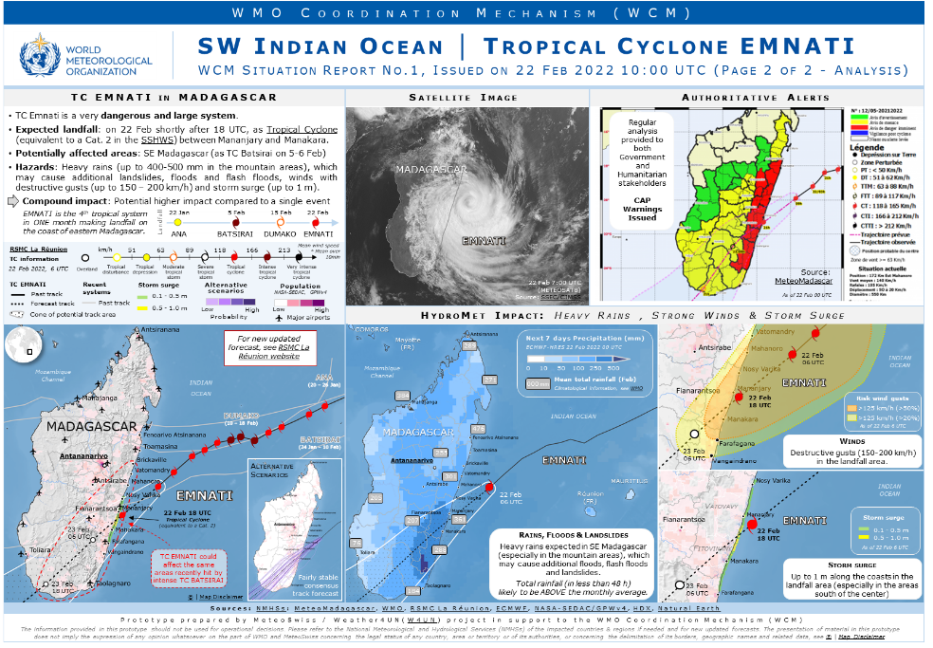
Figure 5: WCM/MeteoSwiss W4UN Prototype – SW Indian Ocean Info Graphic
Ad Hoc Support – Requests for support to UN Anticipatory Action and Response activities also include:
• UNHCR Afghanistan Winterisation Planning
• UNHCR Khartoum Flood Response
• Multi-Agency East Africa Drought Anticipatory Action and Risk Assessments (Figure 6)
• TC Batsiria UN SG Briefings
• IASC Hurricane Season Briefing
• OCHA (MENA) seasonal planning
• Various other requests for information and advice
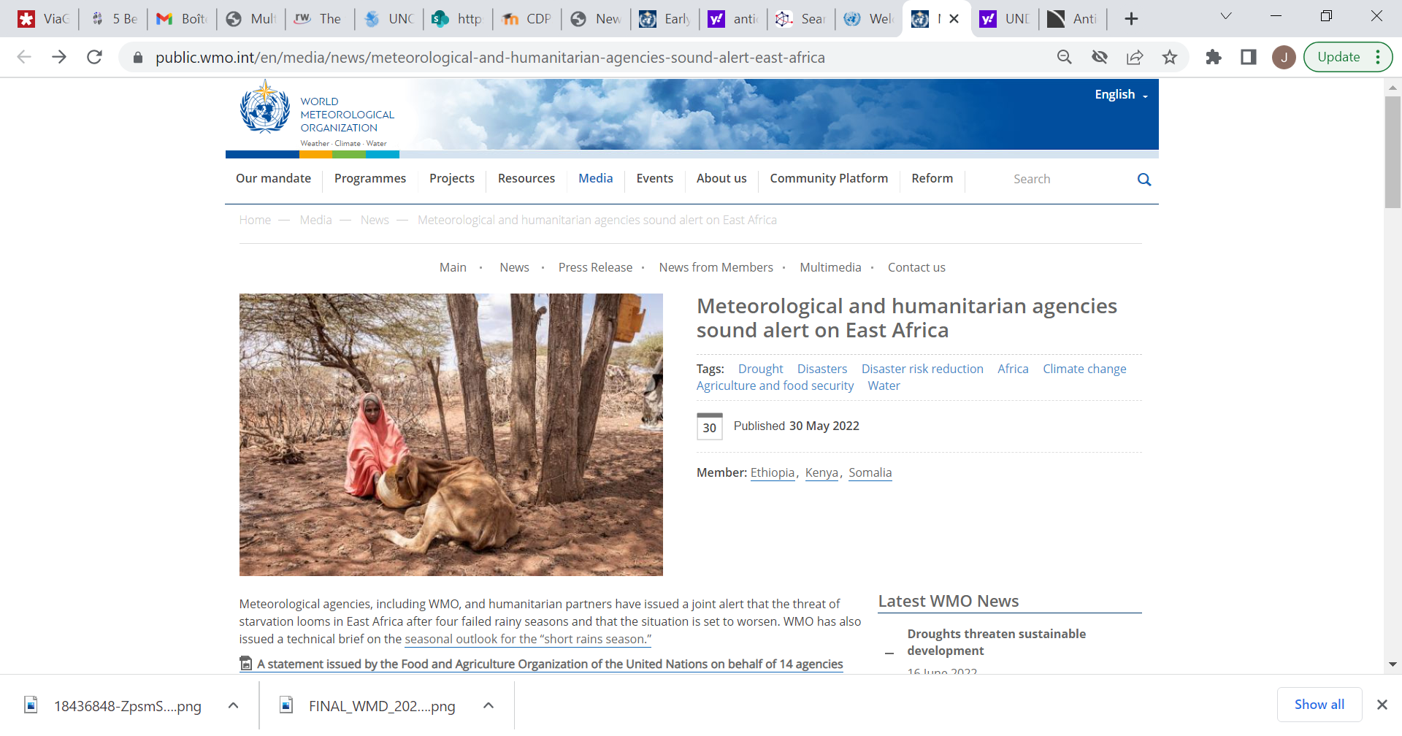 | 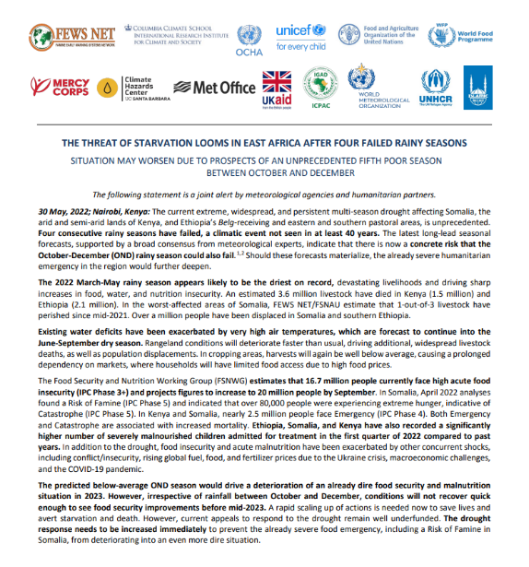
Figure 6: Providing consensus seasonal information for anticipatory actions by UN and Humanitarian Agencies – Greater Horn of Africa 2022

Annex 3 CBT Secondee Requirements & Experience
STANDARD MINIMUM QUALIFICATIONS
Education: University degree in meteorology, environmental science, or related field
Experience: At least 5 years’ experience in short-range weather forecasts and sub-seasonal to seasonal forecasting, hydrological, natural hazard early warning systems, and impact-based forecasting
Language: Fluency (level C) in the English language. Intermediate knowledge (level B) of a second official UN language: Arabic, Chinese, French, Russian, Spanish
KNOWLEDGE & SKILLS:
Working knowledge of seasonal forecast models, Forecast-based Financing, agricultural forecast models.
Knowledge about key UN / HA focus areas and respective climate regimes
Ability to translate complex hydrometeorological information into non-technical actionable advice for decision makers
Ability to work with minimal supervision and set priorities.
Ability to communicate clearly both orally and in writing.
Ability to work in a team and establish effective working relations with persons of different national and cultural backgrounds.
Experience with NCL, GrADS, R, Python, GIS, or similar is desirable.
COMPETENCIES:
Public Weather Services Competency Framework:
• Public weather service advisers supporting disaster prevention and mitigation and other user activities
• Personnel working in the development and delivery of meteorological and hydrological products and services
• Weather broadcasters and communicators

Annex 4 WMO Inter-Agency Standing Committee (IASC), Early Warning / Early Action Assessment Group Draft SOP Schematic
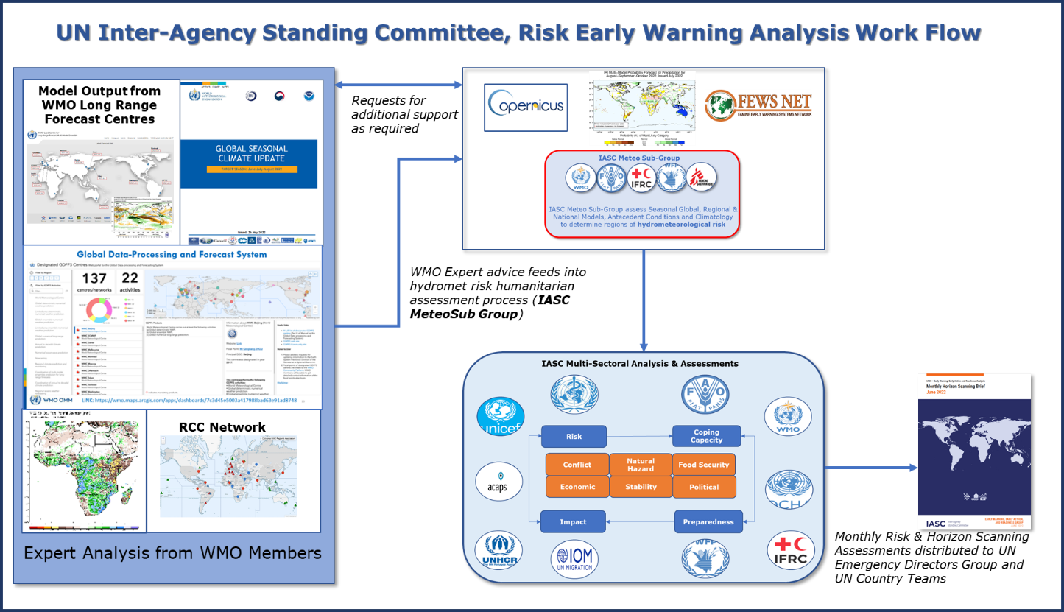

IASC SOP
Model output from Global Seasonal Climate Update (GSCU), LRFMME, Global Producing Centre’s (GPC), RCC, RCOF’s and individual Members feeds into a IASC Meteo Sub Group discussions where experts from WMO, IFRC, FAO, WFP and others consider likelihood hydrometeorological impacts on Humanitarian areas of concern.
This ‘consensus’ assessment then feeds into a wider multi-sectoral risk and horizon scanning discussions where natural hazard, political, security and food security risks are assessed.
Risks are then prioritized with those considered most important briefed into the UN Emergency Directors Group (EDG).

Annex 5 WCM Linkages with WMO Initiatives, Constituent Bodies, and other UN / HA initiatives
This list will evolve and develop over the lifetime of the WCM
SERCOM/SC-DRR
• ET-GMAS: Expert Team on Global Multi-Hazard Alert System
SERCOM/SC-CLI
• ET-CSISO: Expert Team on Climate Services Information System Operations
• ET-CID: Expert Team on Climate Information for Decision-Making
SERCOM/SC-AGR
• ET-DRG: Expert Team on Drought (ET-DRG)
WMO GDPFS related centres
GFCS
INFCOM/SC-ESMP and Data Policy
Standing Committee on Hydrological Services
Hydrology Coordination Panel
WMO Tropical Cyclone RSMCs
WMO Tropical Cyclone Warning Centres
WMO Office to the United Nations in New York
WMO Regional Offices
WMO Regional Associations
WMO Education & Training Team (Member Services Department)
WMO UNDRR Centre of Excellence for Disaster & Climate Resilience
WMO / UN SG Early Warning Initiative

UN / HA
IFRC Anticipation Hub
United Nations Assessment and Coordination Teams (UNDAC)
Risk Informed Early Action Partnership (REAP)

Annex 6 Proposed initial monitoring and reporting indicators of the WCM
1. Overall WCM Implementation
o Status of implementation for each work packages as per planned timeline (After completion of each work package of the CBT)
o Monitoring resource processes of the WCM (including staffing, financial resources, infrastructure)
2. Coordination and Briefing Team Implementation
• Provision of support and advice:
o Number of requests for support as per type
o Minimization of time between requests and delivery
o Feedback regarding the development and prototype of infographics and other products. Procedure for periodic review of products.
o Feedback regarding the provision of support
• Access to data and information:
o Number of requests for access to data per location (region)
o Minimization of time between collection and assembly of Members information and delivery to the UN and Humanitarian Agencies
• After-event reviews:
o Number of event reviews
o Number of stakeholders involved??
o Verification: Relevance of specific triggers or thresholds in initiating anticipatory action
• Overall interactions between the WCM, WMO Members and UN/Humanitarian Agencies
o Number of interactions
o Number of hours spent by the WCM per intervention
o Number of reports produced
o Feedback received as to relevance of interventions
3. Training
• Use of current training available per season
o Number of participants per offerings
o Feedback received as to relevance of training offering
o Use of WMO Global Campus/Learn mechanisms for outreach and access
4. Communication
o Number of activities per type of target audience

Annex 7 Risks & Mitigation
The risk assessment from the key tasks of the Implementation Plan and recommendations are presented as mitigation measures. The analysis presents the findings on the most critical risks and considers the implementation of the WCM CBT and the Network of Regional Advisers as presented in Chapter 4.
Risk | Mitigation
Inability to recruit required number of Seconded Experts to CBT | • Outreach to WMO Members prior to CG19 to allow long-term planning of Members to second personnel to the CBT. Highlight and communicate benefits of second people to the WCM.  • Accurately define the composition of the CBT.  • Define necessary experience and requirements in recruitment process provided to the expert candidates.  • Ensure that a thorough analysis is completed in order to provide the required human and financial resources.  • Seek an alternative means of resource mobilization by exploring funding options with Members, Donors, UN / HA.  • Reduce service delivery until resourcing issues are resolved.
Potential secondees do not have the required level of expertise | • Provide secretariat support for an extended period of time while secondees gain experience.  • Develop succession planning to ensure any future secondees have the opportunity to gain the required experience prior to deployment in the WCM.
Lack or limited voluntary support from WMO Members for the establishment of cooperation agreements and for the provision of information/data. | • Through briefings and outreach ensure that the Members understand the need for the WCM and their role within the WCM including the benefits which they, HA and other stakeholders will derive from the WCM.
Duplication of infographics and/or products with respect to what was developed by the Members. | • Socialize new requirements with Members to reduce risk of duplication.
Lack of engagement of some actors in activities of the WCM (for example, after-event reviews) limits continuous improvement and hinders the support provided by the WCM | • Elaborate a continuous improvement program between UN and Humanitarian Agencies and the Briefing Team.  • Develop indicators related to the activities and coordination between the WCM and the UN and Humanitarian Agencies. Ensure documentation of activities.  • As above, highlight and communicate benefits of the WCM.  • Ensure regular communication with Members involved.
Failure of communication mechanisms/information does not arrive in a timely or required manner | • Determine the mechanism of communication between UN, Humanitarian Agencies and the Team to establish priorities and schedules of work for timely decision-making.  • Contingency plans in place and regular review of SoPs.  • Regular meetings with relevant stakeholders to ensure follow-up on after-event reviews and Quality Management.
UN / HA may ask WMO to accept accountability for Anticipatory Action or Response decisions made on WCM advice | • Agree terms of user policy with partner UN / HA
UN / HA / Inter Government Agencies look to establish their own Hydrometeorological Teams to deliver bespoke agency specific and task-oriented advice | • Develop a programme of outreach and briefings to ensure requirements and role of the WCM are fully understood. Where dedicated hydrometeorological teams are established work with UN / HA to ensure partnerships are developed with the Members and the WCM
Tension develops between the WCM and Members around the provision of support to the UN and HA | • Ensure an effective update process is provided to Members through regional forums so that Members have a formal route to raise queries at an early stage.

_______________

EC-75-d04(2)-UN-GLOBAL-EARLY-WARNING-ADAPTATION-INITIATIVE-approved_en.docx (wmo.int)
Any reference to incorporating WCM in existing frameworks and normative documents will be defined during the lifetime of WCM Implementation
ET-WCM, WMO Members representatives from British Caribbean Territories, Canada, Chile, China, Columbia, Germany, Mozambique, Niger, Philippines, Switzerland, and representatives from IFRC, WFP, UNOCHA
ET-WCM_Introductory_Meeting_Information_Scoping_Paper_08122020.docx (sharepoint.com)
See link to Resolution 14, in Annex 1 [SEC]
Products and advice will be shared when practical or permissible to do so
The WCM will aggregate Members Information, data, advice and expertise, the WCM will not develop or issue its own forecasts
Once established and after an agreed period of time it may be possible to transition the CBT from a Geneva based team to one which is more virtual in nature, however it is anticipated that for the first 12 months at least that the team will need to be based in the WMO Secretariat in Geneva.
United Nations Operations and Crisis Centre (UNOCC) office located in New York
Such as RCC Climate Watch Advisories, ICPAC Support to Horn of Africa Food Security Nutrition Working Group (FSNWG), Regional Climate Outlook Forums etc
MANAGEMENT AND ACCOUNTABILITY FRAMEWORK OF THE UN DEVELOPMENT AND RESIDENT COORDINATOR SYSTEM
IASC Terms of Reference for Humanitarian Coordinators | HumanitarianResponse
WMO Regional Climate Centres | World Meteorological Organization
Severe Weather Forecasting programme (SWFP) | World Meteorological Organization (wmo.int)
This may be a new Expert Team or another WMO construct as advised by SERCOM.
Welcome to the IASC | IASC (interagencystandingcommittee.org)
The IASC Meteo Sub-group includes participants from WMO, ECMWF, WFP, FAO, UNOCHA
Inter-Agency Standard Operating Procedures for Early Action to El Niño-La Niña Episodes.pdf (interagencystandingcommittee.org)

